GARVIL JAIN 2022UCP1302 ASSIGNMENT-3

BRUTE FORCE
#include <iostream>
#include <string>
using namespace std;

string decrypt(string text, int shift) {
string result = "";
for (int i = 0; i < text.length(); i++) {
if (isupper(text[i])) {
result += char(int(text[i] - shift - 65 + 26) % 26 + 65);
} else if (islower(text[i])) {
result += char(int(text[i] - shift - 97 + 26) % 26 + 97);
} else {
result += text[i];
}
}
return result;
}

int main() {
string cipherText;
cout << "Enter the cipher text: ";
getline(cin, cipherText);

cout << "\nBrute Force Analysis:\n";
for (int shift = 1; shift < 26; shift++) {
cout << "Shift " << shift << ": " << decrypt(cipherText, shift) << endl;
}

return 0;
}

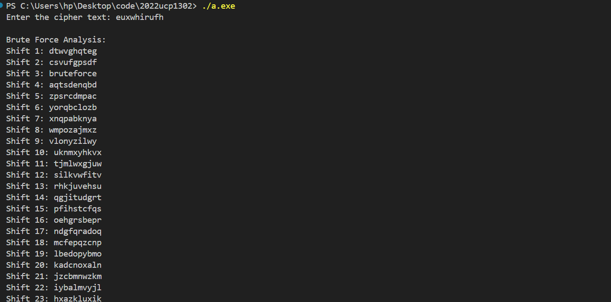

FREQUENCY ANALYSIS
#include <iostream>
#include <string>
#include <vector>
using namespace std;

int findMostFrequentLetter(string text) {
vector<int> frequency(26, 0);
for (char c : text) {
if (isalpha(c)) {
frequency[tolower(c) - 'a']++;
}
}
int maxFreq = 0, mostFrequentIndex = 0;
for (int i = 0; i < 26; i++) {
if (frequency[i] > maxFreq) {
maxFreq = frequency[i];
mostFrequentIndex = i;
}
}
return mostFrequentIndex;
}

string decrypt(string text, int shift) {
string result = "";
for (int i = 0; i < text.length(); i++) {
if (isupper(text[i])) {
result += char(int(text[i] - shift - 65 + 26) % 26 + 65);
} else if (islower(text[i])) {
result += char(int(text[i] - shift - 97 + 26) % 26 + 97);
} else {
result += text[i];
}
}
return result;
}

int main() {
string cipherText;
cout << "Enter the cipher text: ";
getline(cin, cipherText);

int mostFrequentLetterIndex = findMostFrequentLetter(cipherText);
int assumedShift = (mostFrequentLetterIndex - ('e' - 'a') + 26) % 26;

cout << "\nMost Likely Shift (Based on Letter Frequency Analysis): " << assumedShift << endl;
cout << "Decrypted Text: " << decrypt(cipherText, assumedShift) << endl;

return 0;
}

